Grading Guidelines:

A right answer will get full credit when:

1. It is right (worth 25%)
2. It is right **AND** neatly presented making it easy and pleasant to read. (worth an **extra** 15%)
3. There is an **obvious and clear link** between 1) the information provided in the exercise and in class and 2) the final answer. A clear link is built by properly writing, justifying, and documenting an answer (worth an **extra** 60%).
4. Calculation mistakes will be minimally penalized (2 to 5% of full credit) while errors on units will be more heavily penalized.

**Late Submission** : as specified in the syllabus. Days counting starts one minute after the deadline.

**Check Your Submission:**  after submitting, download your submission to check whether it is the right version and it is complete.

You are welcome/encouraged to discuss exercises with other students or the instructor. But, ultimately, **personal** writing is expected.

* USE THIS FILE AS THE STARTING DOCUMENT YOU WILL TURN IN. **KEEP IN THE QUESTIONS** AND INSERT YOUR ANSWERS.
* IF USING HAND WRITING (STRONGLY DISCOURAGED), REWRITE THE QUESTIONS.
* FAILING TO FOLLOW TURN IN DIRECTIONS /GUIDELINES WILL COST A 30% PENALTY.

Objectives of this assignment:

* to learn independently about an important topic
* to answer questions about the independently studied topic
* to empower you: you can learn any networking topic on your own
* to learn independently new concepts

What you need to do:

Answer the questions and/or solve the exercises described below.

Objective: The objective of this assignment is to learn independently about *Network Address Translation (NAT)*. You must research and read about NAT, and then answer the questions.

Resources:

1. **Textbook:** Tanenbaum, Andrew S. and David J. Wetherall. *Computer Networks*.
2. Module 5
3. Your instructor (Through Piazza)
4. RFC 3022
5. Wikipedia (complete, but may be confusing)
6. Internet

Note that the textbook, Module 2 material, and your instructor are sufficient to answer all questions in this homework as well as the related self-study questions.

**Questions**: (**hint**: read first all questions before answering. This will avoid you repeating or overlapping answers).

**Generalities**

1. **(5 points)** Which problem does NAT address or solve?

**-** The NAT address security and reduces the number of IP addresses needed for the organization.

2) **(15 points)** Explain briefly what NAT is (about 5 to 10 lines). Feel free to refer to **Figure 5-55** below to help your explanations.

**-**NAT acts as a firewall or router and sits between an internal network and the rest of the world. It maps address to each other by changing the header of IP packets while in transit via a router. It takes any amount of devices you have on your local network and allow them to use a single and unique IP address on the Internet. Most organizations that want multiple device to employ a single IP address use NAT, as do most home routers.

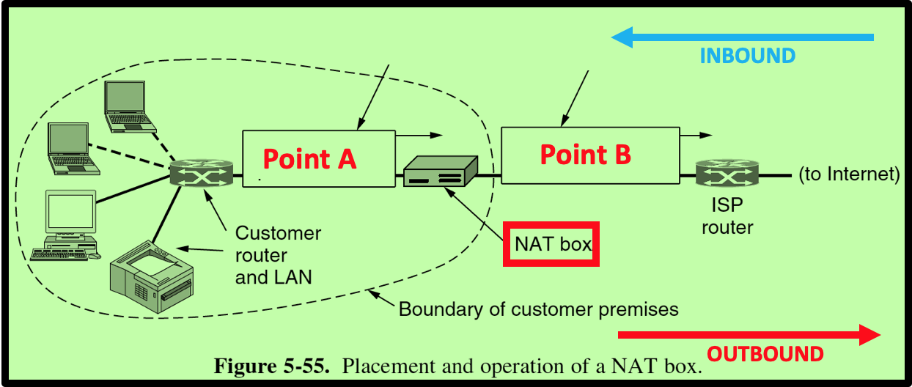

1. **(5 points)** Suppose you want to deploy NAT at your home. Do you need to contact some Internet organization/authority or your Internet provider to get assigned some range of IP addresses to use on your **internal** network?

- I do not believe you need to contact your provider to deploy NAT at home. According to Cisco IOS, you can setup Inside and Outside NAT to help configure traditional NAT.

4) **(5 points)** What is (are) the range(s) of IP addresses you could use on your internal network?

- The ranges of IP addresses you could use for your internet network consist of:

* 10.0.0.0 – 10.255.255.255/8, which has 16,777,216 host,
* 172.16.0.0 – 172.31.255.255/12, which has 1,048,576 hosts, and
* 192.168.0.0 – 192.168.255.255/16, which has 65,536 host.

5) **(5 points)** Does your wireless network at home use NAT? What is the IP address of your desktop, laptop, or any device you use to access Internet from home?

- I believe my internet is behind NAT because my public IP address is 131.204.254.86. My device’s IP address is 172.19.99.179 as is listed under my settings next to IPv4.

6) **(5 points)** Suppose that you want to use NAT on your network at home. What is the smallest number of external (Internet) IP addresses you would need to acquire from your Internet provider?

- The smallest number of IP addresses needed for a NAT at home is 2, a public IP and a private IP.

**NAT Operations**

First let us define a **flow**: *two packets belong to the same TCP (or UDP)* ***flow*** *if both packets carry a TCP segment (or a UDP datagram) that have the* ***same*** *source IP address, destination IP address, source port number, and destination port number.*

For all the following questions, we assume that the NAT box has the following available ports for translation for TCP and UDP. When the NAT box needs to translate a packet for a **new** flow, it will pick the next available port number from the table below. We assume that the next available port number for TCP (resp., UDP) is at Index 1. If the port number at Index 1 is already used, the next available will be the one at Index 2 and so on. **We assume that the NAT was just turned on**. Therefore, the next available port # for translation of a TCP (resp. UDP) flow is 7209 (resp. 10201).

|  |  |  |
| --- | --- | --- |
| Index | TCP | UDP |
| 1 | 7209 | 10201 |
| 2 | 6170 | 2750 |
| 3 | 1463 | 1070 |
| 4 | 1078 | 2553 |

As seen on Figure 5-55, a customer sets up a network with multiple machines. However, the Internet provider assigned only one IP address to the customer: this IP address is 128.204.27.177.

Consider a machine M on the customer's network "behind" a NAT box, i.e. on the premises of the customer (see Figure 5-55 above). The IP address of Machine M is 192.168.45.172. A TCP client socket is established at Port # 10100 to send an http query ***Q*** to the server at IP address 64.233.110.188.

1. **(10 points)** Consider Packet P1 carrying the http request ***Q.*** P1 **leaves** Machine M and reaches Point A (see Figure 5-55). Fill in the array below with the source IP address, destination IP address, source port number, destination port number of Packet P1 when it is at Point A. Tell whether this packet P1 carries a TCP segment or a UDP datagram.

|  |  |  |  |  |
| --- | --- | --- | --- | --- |
| TCP or UDP? | IP Source | IP Destination | Source Port # | Dest. Port # |
| UDP | 192.168.48.172 | 64.233.110.188 | 10100 | 80 |

1. **(10 points)** When the NAT box receives Packet P1, it translates it and outputs on Point B (see Figure 5-55) a translated packet. Fill in the array below with the source IP address, destination IP address, source port number, destination port number of the **translated** Packet P1. Highlight the information that will change (by the translation) and explain why.

|  |  |  |  |  |
| --- | --- | --- | --- | --- |
| TCP or UDP? | IP Source | IP Destination | Source Port # | Dest. Port # |
| UDP | 128.204.27.177 | 64.233.110.188 | 10201 | 80 |

- The source port # has changed because it was translated through the NAT box as the first possible ports of UDP.

3) **(10 points)** When Packet P1 reaches the server, the server will respond with a packet **P2**. Fill in the array below with the source IP address, destination IP address, source port number, destination port number of the Packet **P2**.

|  |  |  |  |  |
| --- | --- | --- | --- | --- |
| TCP or UDP? | IP Source | IP Destination | Source Port # | Dest. Port # |
| UDP | 64.233.110.188 | 128.204.27.177 | 80 | 10201 |

4) **(10 points)** When the inbound packet P2 reaches the NAT box, it will be translated. Fill in the array below with the source IP address, destination IP address, source port number, destination port number of the **translated** Packet P2 (Point A).

|  |  |  |  |  |
| --- | --- | --- | --- | --- |
| TCP or UDP? | IP Source | IP Destination | Source Port # | Dest. Port # |
| UDP | 128.204.27.177 | 192.168.48.172 | 10201 | 2750 |

-The next translated port # from the NAT in UDP is the port # 2750.

5) **(10 points)** Suppose now that the same machine M (IP address :192.168.45.172) makes a DNS request to the server at IP address 128.194.34.204. The DNS client is bound to Port # 10020. The DNS request will be carried by Packet P3. Fill in the array below with the source IP address, destination IP address, source port number, destination port number of Packet P3 (Point A).

|  |  |  |  |  |
| --- | --- | --- | --- | --- |
| TCP or UDP? | IP Source | IP Destination | Source Port # | Dest. Port # |
| UDP | 192.168.48.172 | 128.194.34.204 | 10020 | 53 |

6) **(10 points)** When the NAT box receives Packet P3, it translates it and outputs on Point B (see Figure 5-55) a translated packet. Fill in the array below with the source IP address, destination IP address, source port number, destination port number of the **translated** Packet P3. Highlight the information that will change (by the translation) and explain why.

|  |  |  |  |  |
| --- | --- | --- | --- | --- |
| TCP or UDP? | IP Source | IP Destination | Source Port # | Dest. Port # |
| UDP | 128.204.27.177 | 128.194.34.204 | 1070 | 53 |

* The next translated port # from the NAT box in UDP is port # 1070.

**What you need to turn in**:

* Electronic copy of this file (including your answers) (standalone). Submit the file as a Microsoft Word or PDF file.
* Recall that answers must be well written, documented, justified, and presented to get full credit.
* How this assignment will be graded:
* A right answer will get full credit when:
* It is right (worth 25%)
* It is right AND neatly presented making it easy and pleasant to read. (worth 15%)
* There is an obvious and clear link between 1) the information provided in the exercise and in class and 2) the final answer. A clear link is built by properly writing, justifying, and documenting an answer (worth 60%).
* Calculation mistakes will be minimally penalized (2 to 5% of full credit) while errors on units will be more heavily penalized.
* You are welcome/encouraged to discuss exercises with other students or the instructor. But, ultimately, personal writing is expected.